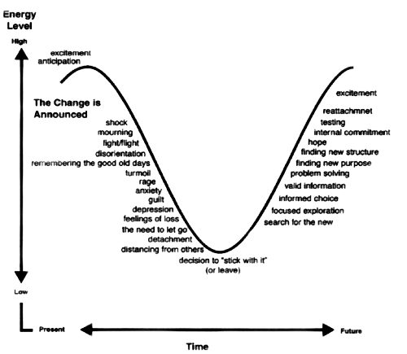

Gil Rendle Leading Change in the Congregation: Spiritual and Organizational Tools for Leaders, Alban Institute.

